

**National Animal Disease Reporting System – User Manual – District and State Level Users**

[http://www.navayugainfotech.com/images/logo.jpg](http://www.navayugainfotech.com/index.htm)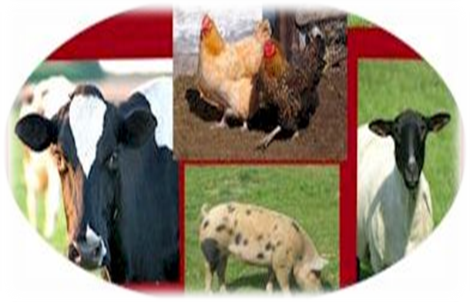

User Manual

District and State Level Users

Animal Production and Health Informatics Division

National Informatics Centre

Department of Information Technology

Ministry of Communications & Information Technology

Government of India

Navayuga Infotech Pvt Ltd;

124, 3rd Floor,

Surya Chambers, Murugash Palya, Airport Road

Bangalore – 560 017

National Animal Disease Reporting System

**2012**

**Department of Animal Husbandry, Dairying & Fisheries**

Ministry of Agriculture

Government of India

National Animal Disease Reporting System

(User Manual – District and State Level Users)



Animal Production and Health Informatics Division

National Informatics Centre

Department of Information Technology

Ministry of Communications & Information Technology

Government of India

Table of Contents

1 Overview 4

1.1 Background 4

1.2 Objective 7

1.3 Scope 7

1.4 Document Structure 7

1.5 Keyboard Shortcuts 8

2 Screen Layout for NADRS 8

3 System Basics 9

3.1 How to login 9

3.2 How to Logout 9

4 Disease Reporting 10

4.1 How to View a Daily Incidence Disease Case 11

4.2 How to view First Information Report 21

4.3 How to Approve and Return First Information Report 31

5 How to generate reports 36

6 Disease Reporting By External User 40

6.1 View an Unstructured Report submitted by external User 40

6.2 Analyze a structured Report 42

Annexure - I Keyboard Shortcuts 44

Annexure - II Animal Disease Reporting – Workflow 46

a. Daily Incidence Case 46

b. First Information Report (FIR) 47

Annexure - III Reports 48

# Overview

## Background

The National Animal Disease Reporting System, in short NADRS, is a new Centrally Sponsored Scheme proposed for implementation during last three years of the 11th Five Year Plan with cent percent Central assistance.

India has a large animal population comprising, as per Livestock Census (2003), 485 million of livestock and a one-time count of 489 million poultry. Livestock also plays an important role in India’s economy, contributing (along with fisheries) 5.21% to the country’s GDP and 31.6% to the agriculture GDP in 2007-08. The livestock sector has immense potential. It has emerged as the key driver of agricultural growth in the country.

The biggest impediment to growth of this sector, however, is the large-scale prevalence of diseases such as Foot and Mouth Disease (FMD), Haemorrhagic Septicaemia (HS), Black Quarter (BQ) in cattle, Enterotoxaemia, Peste des Petits Ruminants (PPR) & Sheep-Goat Pox in sheep and goats and Swine Fever in pigs, which drastically affect the productivity of animals. The presence of animal diseases also deters domestic and foreign investment in the livestock sector. These diseases not only wreck havoc on the existing stock but also constrain market access to our livestock sector, in spite of the fact that we have ample scope to participate in the global trade.

The economic impact of the diseases in livestock results from both morbidity and mortality and the consequent production losses. This includes the direct losses due to mortality, reduced production in terms of milk, meat, wool, hide and skins, as well as indirect loss due to abortions, subsequent infertility, sterility, and deterioration of semen quality. Controlling animal diseases is of upmost important for to prevent these losses and livestock industry to progress for the benefit of the livestock farmers.

At present, an animal disease is primarily recorded by the veterinary doctor working in a Government hospital / dispensary on the basis of clinical diagnosis. This information is passed on to the Taluka / Block level and then to the District and the State veterinary authorities. Disease information is also generated from the disease diagnostic laboratories at the District, State or regional level on the basis of laboratory diagnosis. Finally, information from State level is transmitted to the Central Government, i.e., the Department of Animal Husbandry, Dairying & Fisheries (DADF) in New Delhi. The DADF notifies the World Animal Health Organization (OIE) and other international organizations, as appropriate.

The present system of animal disease reporting is not satisfactory for the following reasons:

The disease reporting is neither timely nor complete. As a result of reliance on postal means of communication, the reports and returns take considerable time and some are also lost in transit. Hence, the compiled information does not represent true picture of the disease situation at any given point of time.

The veterinary services available in the country are grossly inadequate. As a result, a large portion of the livestock owners do not have access to the Government veterinary services. These people rely on either the traditional systems of veterinary medicine or the private veterinary services. These incidences of animal diseases remain out of the reporting system. Their number is believed to be significant.

In the prevailing situation, many times animal diseases assume serious proportion before control and containment steps can be initiated, thereby causing avoidable social and economic costs on the livestock owners and the country’s economy.

In order to bring about desired change to the existing situation, a computerized system of animal disease reporting is being introduced, linking each Taluka / Block, District and State Headquarters to a Central Disease Reporting and Monitoring Unit at the DADF in New Delhi. The diagrams given below depict the NADRS contemplated diagrammatically, along with various agencies who would be expected to contribute data to the system and its transmission to the Central Monitoring Unit in the DADF at New Delhi.

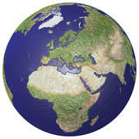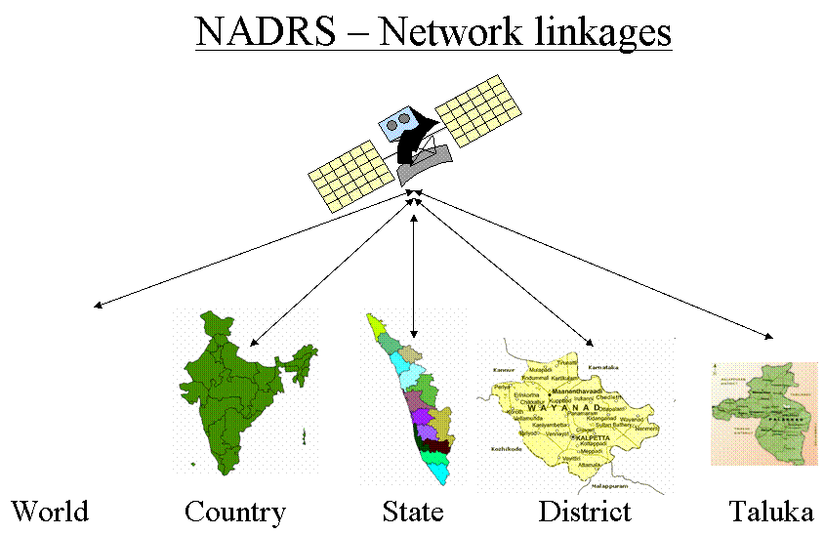The reporting system envisaged will enable the Block, District and State animal health officials to report the disease information and render reports and returns prescribed in this regard via internet. The system will be so designed as to assure secure data transfer and confidentiality of information. At the apex level, NADRS will compile and generate animal disease information for the country as a whole. The users will have access to the information as per permissions in consonance with their role and responsibilities envisaged under the system. This computerized system, proposed to be called ‘National Animal Disease Reporting System’ (in short NADRS), will enable fuller and timely reporting of the animal disease situation in the country, enabling its effective management.

State Monitoring Unitat AH Directorate

DistrictUnit

BlockVeterinaryHospital

VeterinaryDispensary**/**Hospital

NGOs

Farmers/ Livestock Owner

Private Veterinary Practitioners

Local bodies

Regional / National Laboratory

State Laboratory / Veterinary College

Stockman/sub-centers

Central Monitoring Unit (CMU)

DistrictLaboratory

As a result of the information that would emerge from the NADRS, it would be possible to develop disease forecasting models, leading to development of disease prevention strategies. As the proposed scheme aims at effective monitoring the occurrence of livestock diseases with a view to enabling their early control, it will result in improving the livestock health in the country. By the very nature of the benefits that would accrue, these cannot be quantified in concrete terms. There is, however, no doubt that implementation of the scheme will yield immediate benefits to the livestock owners and to the economy by way of better health status of animals, prevention of losses due to their morbidity and mortality and improvement in the quality of their products. The benefits likely to accrue to livestock owners and to the economy may be summarized below:-

Benefits to livestock owners

* Better management of diseases of their livestock
* Availability of veterinary service
* Increased economic gain from higher productivity of animals
* Improved market acceptability of their livestock products

Benefits to animal husbandry administration

* Availability of a common channel for dissemination of animal disease information to all stakeholders
* Availability of SMS-based instant alert system for outbreak of diseases, spread of diseases, remedial measures and expert advice, enabling prompt control of diseases
* Availability of enhanced decision support system with GIS integration for effective and timely decision making

Benefits to economy

* Increased livestock production and productivity
* Improved market acceptability of domestic livestock products in international trade
* Saving of costs otherwise incurred for treatment of animals
* Fillip to the growth of the livestock sector, leading to increased employment generation and higher availability of animal protein to the population

In the beginning the users may find the data entry forms exhaustive, but this is because these are designed to capture all details about the disease reporting. If filled properly, in long run these will be beneficial in the future activities like generating detail reports without going through the manual exercise of referring different registers maintained for it. It would create a very good data bank about animal diseases which can be further used for analytical purposes.

## Objective

The objective of this manual is to guide State and District Level Veterinary Officers in using the Disease reporting module of National Animal Disease reporting System (NADRS).

## Scope

The scope of the manual is limited to the usage by State and District Level Officers.

## Document Structure

This document provides step by step procedure for using Animal Disease Reporting module of National Animal Disease Reporting System

The first section of the document provides background of the project, objective, scope of the document and keyboard shortcuts to be used for faster operations.

The second section provides details of the screen layout.

The third section provides details about login procedure.

The fourth section gives step by step procedure for operation of the system.

The fifth section of the document explains about generation of reports

The Sixth Section provides procedure to handle the reporting about animal disease by external users through web interface, e-mail, IVRS, etc.

## Keyboard Shortcuts

User can use Keyboard shortcuts to speed up the data entry. These shortcuts have been provided in Annexure - I

# Screen Layout for NADRS

Each screen of the NADRS system has been divided in three parts. Top part is ribbon displaying all action buttons as given below

New- To add new record

Edit – To edit the record which was entered earlier

Delete – To delete the record

Run Report – To access the report

Filter – To display specific set of records defined by filter criteria

Advance Find – To search particular records.

These buttons are context sensitive and enable/disable as per the context of the active window/form/part of the selected item.

Left pane displays menu and submenus for selecting action. Right pan displays activity list/forms/reports as per user selected item. The following figure depicts these parts.

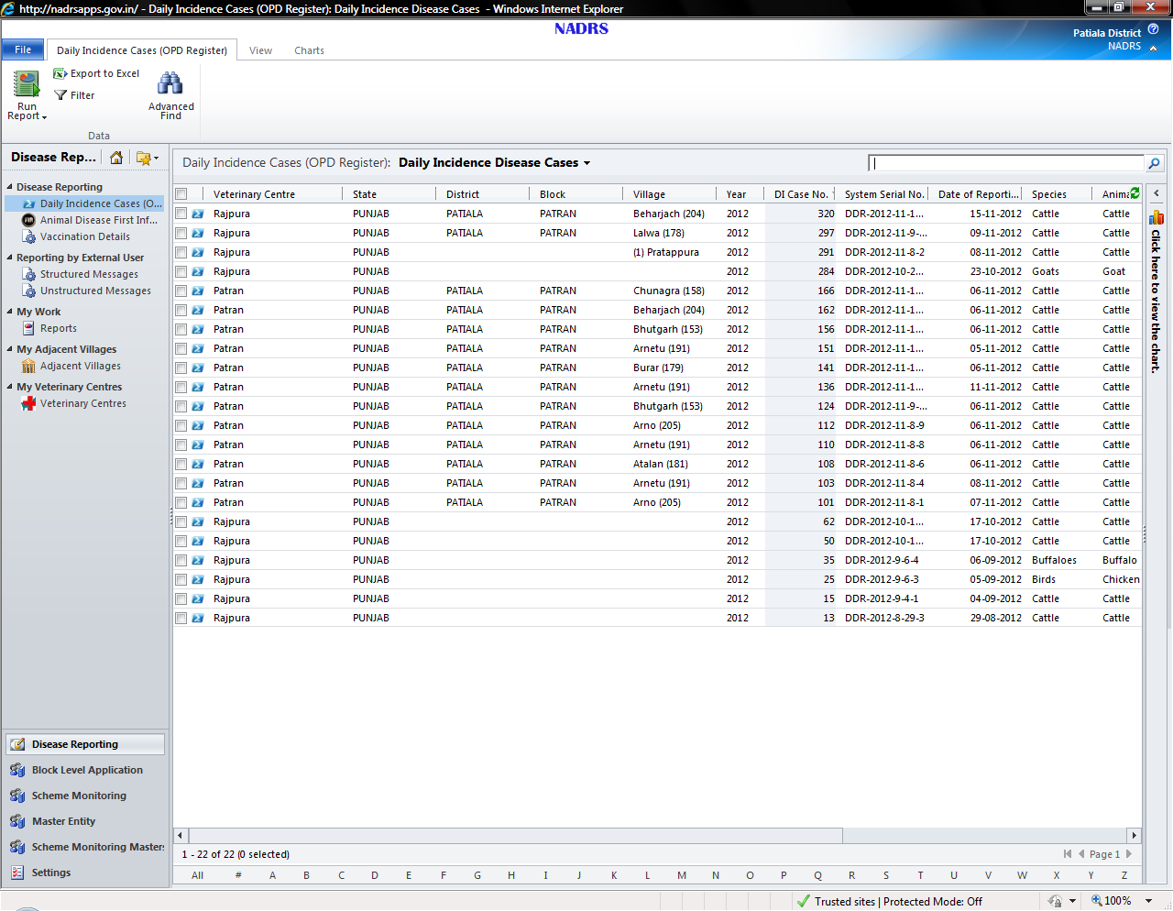

Top Ribbon displaying action buttons

Left Pane to display menu and submenus

Search Box

Right pane to display activity list, form, report

# System Basics

## How to login

|  |  |
| --- | --- |
| **Step** | **Action** |
| **1.** | **Display the login screen**   * Launch the Internet Explorer and type the organization URL(http://nadrsapps.gov.in)#. User will be prompted for entering login information.   # Kindly note that URL registration is under process. So user may access the application using the procedure explained by Trainer. |
| **2.** | **Enter Login Information**  Enter the username and password and click on login button. |

## How to Logout

|  |  |
| --- | --- |
| **Step** | **Action** |
| **1.** | **Logout from the system**  Close the session for logging out of the system. |

# Disease Reporting

The default page shows the dashboard of the user displaying list of Daily Incidence Disease Cases with dynamically fetched information of the diseases.

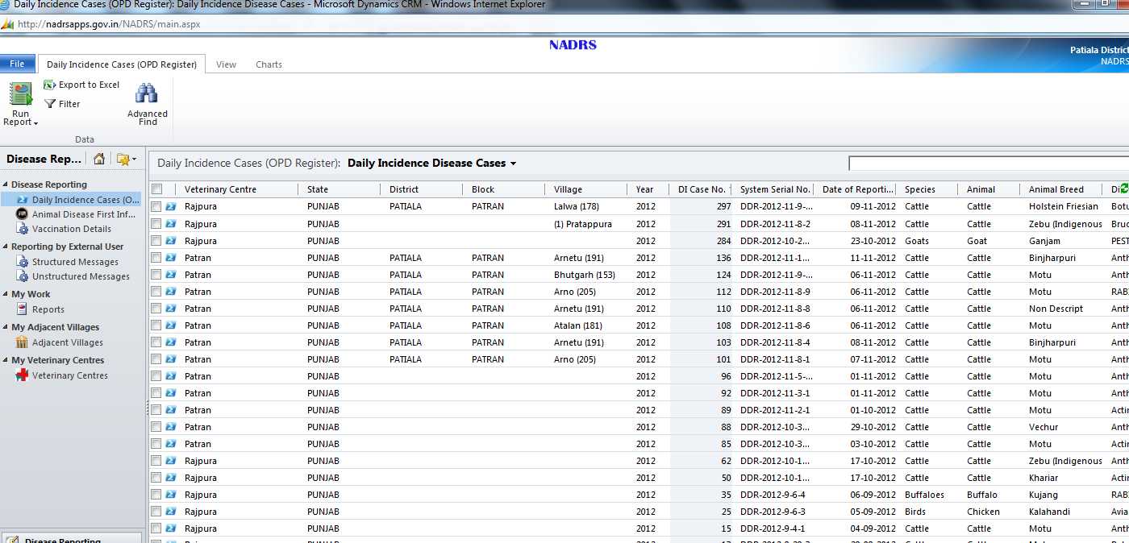

|  |  |
| --- | --- |
| **Step** | **Action** |
| **1.** | **Selecting the required option**   * Select the required option from the left hand side pane from three options available  1. Daily incidence disease cases 2. First Information reports 3. Vaccination Details |

## How to View a Daily Incidence Disease Case

|  |  |
| --- | --- |
| **Step** | **Action** |
| **1.** | * **Selecting Daily Incidence Disease Case Option**   Select the option Daily Incidence Disease Case    The list of cases would be shown in the grid as follows- |
| 2. | Open a Record to view the details.   * Double click on the selected record. Daily incidence record created by veterinary doctors of concerned Block under the district will be displayed. In case of State level users all records entered by veterinary doctors in his state will be displayed. State and District level users can only view these records. |
| 3. | A new window will be opened which contains all the necessary details for the daily incidence case. |
| **4.** | **Field details:**   * **Location Details :**      * Veterinary Centre- Veterinary Centre, where the case has been registered * State- State in which the centre is located * District- District in which the centre is located * Rural/Urban- If the place is Rural or Urban * Block- Name of the Block in which the Centre is located * Village- Name of the village under the block from where case has been registered * **Case Information :**      * Case – New/Repeat/Referred case. * Date of Reporting –date on which the case is reported * Animal Owner – Name of animal owner * Patient Type- Out-Patient/In-Patient/Health Camp/On tour. * Veterinary doctor: Name of the doctor who is treating the animals * Case status - Active/Closed * Patient Status – Successfully Treated/Under treatment/ Dead * **Animal Details:**      * Species Category- Specifies the category of the animal as domestic, migratory, pet, wild * Animal Habitat- Specifies the animal habitat as farmer, farms, zoo, bird sanctuaries, and stray animals * Species- Specifies the Species of the animal * Animal- The animal of the specified species * Animal breed- Specifies the breed of the animal * Number of animals- Number of animals brought for treatment * Cause for disease  1. Normal 2. Fire 3. Earthquake 4. Drought 5. Flood 6. Accident 7. Avalanche   Snowfall   * **Disease Details:**      * Disease – Disease name for which the case is registered * If the selected disease is “Rabies” then the following details will be displayed      * Number of Animals Affected * Name of the animal causing infection. * Vaccination Prophylactic and Vaccination Post exposure has been administered or not. * Number of deaths Before Vaccination and After Vaccination. * If the selected disease is “Bovine Spongiform Encephalopathy” then the following details will be displayed.      * Vaccination has been done or not (Yes/No) * Number of animals dead * Number of humans exposed * Enter number of human deaths * If the selected disease is “Glanders” then the system will display the following details        * Number of animals examined * Number of animals at risk * Number of animals died. * If the selected disease is “Toxic case” then the system will display the following details      * Source of Poisoning is shown by the selected check box * Number of Deaths-Number of animals died due to poisoning * Source of Poisoning food- Source by which the food has been poisoned. * If the selected disease is “Bulls STD” then the system will display the following details      * Number of animals affected – Number of animals affected due to the disease * Number of animals died- Number of animals died due to this disease * **Disease Symptoms:**      * Shows symptoms which are selected for that case. * **Animal Wise details:**      * Show the animal wise detailed record * Select record and double click on it to see the animal details * **Treatment details:**      * Case Treatment will show any one option from the following list  1. Medicinal 2. Surgical 3. Systemic 4. Gynaecological  * Vaccinated - Animal is vaccinated or not. * If “Yes” option is selected, then following information are displayed. * Vaccination date – Date on which animals are vaccinated * Vaccine name – Name of the vaccination * Number of animals vaccinated * **Suspected Outbreak:** If daily incidence case is reported as a suspected outbreak then a First information Report will be created automatically with the same parameters which are entered for the daily incidence case. The following details are displayed in the daily incidence form      * Date of Initial Occurrence – Date on which the disease occurred first time * Date of Visit –Date on which the doctor visited the place where animal resides * Remarks- any special comment or remark * Outbreak confirmed? – This field indicates the suspected outbreak confirmed or not. It will automatically change if this report will be confirmed as outbreak in future. * No. of Animal Affected – Number of animals affected with this disease * No. of death –Number of animal deaths * Source of infection – Source from which the animal has been infected * Disease mode of Introduction- direct/indirect/ both. |
| **5.** | **View animal wise details in Daily incidence case**   * Double click on a record to open it from animal wise details area. * A new window will be opened which looks as follows- |
| **6.** | **Animal Details form**     * Animal Id- Id of the animal * Adult/Young- Specifies if the animal is adult or young * Gender- Male or female * If option Adult and Female is selected as gender then pregnancy status is shown as below-      * Age- The age of the animal * In Y/M/W/D – the age of the animal in year/month/week/days * Exotic/Indigenous/Crossbreed- The type of animal * Lab test recommended- Specifies whether the animal requires lab test or not. If it “No” then no lab test has been undertaken otherwise the lab details can be viewed. * Post Mortem Recommended – Specifies in case of dead animals Post Mortem is required or not. If Yes is selected then a text box will show the Post Mortem findings. |
| **7.** | **Treatments**   * Click on one treatment record from the treatments      * Treatment record form will open that represent the treatment given to the particular animal for selected period. * After clicking Treatment record new window will be opened as follows-     **General:**   * Case Id/Outbreak Id- automatically generated according to Case * From Date- Specifies the date from which treatment has been given * To Date – Specifies the date up to which treatment has been given * Treatment Category-Specifies the category for treatment like Antibiotic, Analgesics and anti inflammatory, IV Fluids etc. * Treatment medicines- List of medicines prescribed to the animal * Save and Close the form by clicking on “Save& Close” button or pressing Esc or Shift+F12. |
| **8.** | **View lab test details of the particular animal.**   * Double Click on Lab test confirmation record from the animal disease details form.      * Existing record form will be displayed.        * **Lab test details for daily incidence case** * Daily incidence serial no. – Auto generated number for daily incidence case * Tentative disease- The disease which is suspected * Date of Reporting- The date on which the reporting of the disease is done * Veterinary doctor confirmation- This gets filled after the lab test result will come. * Veterinary Centre- The name of the Centre where treatment is to be taken place. * Parent lab test and confirmation- field will show information only in Avian Case. * Remarks- Any special comments or remarks * **Lab test Details**      * Sample unique code- The unique code of sample. It is automatically generated by the system. * Mode of transportation- The mode by which the sample is brought to the lab * Specimen/Sample name- The name of the specimen or sample * Purpose of sample collection- The purpose for which the sample is being collected. For example Surveillance, Outbreak confirmation etc. * Sample collection date- Date on which the sample is collected * Lab test category- The category for which the lab test is conducted for example Blood analysis, Urine analysis etc. * Laboratory- Name of the lab where the test is to be conducted * Lab Test Results: Selected test result will be shown in the data grid against lab test which is performed on the sample. * Sample unique code- It is automatically generated according to Lab test name. * Range -It show the normal range of lab test. * Results – the exact value of test which comes after the lab test performed on the samples. * Test Result – Test Result can be Not confirmed, Positive or Negative. * Remarks- Shows additional remarks, some important and useful points. |
| **9.** | **Save & Close inner Forms(Lab Test Details, Animal Disease Details)**   * Save and Close the form by clicking on “Save& Close” button or pressing Esc or Shift+F12.      * Save & Close the animal disease details form. |
| **10.** | * Save& Close the Daily Incidence form. |
| **11.** | Change the main view for the Daily Incidence Cases.   * Click the change view option from the right side of the navigation pane. |

## How to view First Information Report

|  |  |
| --- | --- |
| **Step** | **Action** |
| **1.** | **Selecting the FIR**   * **S**elect the option Animal Disease First Information Report from the left pane.     On selecting this, the already entered cases would be shown in the grid as follows     * Views can be changed by selecting one of the options listed below |
| **3.** | Double click on a record to open it.  A new window will be displayed with all the fields entered by the block veterinary doctor. |
| **4.** | **Field details**   * **Animal Disease First information Report details** * **Location Details** – Where the case has been registered.      * Veterinary Centre- Veterinary Centre name where the case has been registered. * State- State in which the centre is located. * District- District in which the centre is located. * Rural/Urban- Veterinary centre is located in Rural or Urban area. * Block- Name of the Block in which the Centre is located. * Village- Name of the village under the block where case has been registered.      * FIR type- There are two FIR types: * Direct- If the case is registered directly * Indirect- If the case is registered through the Daily incidence case. * Daily incidence Disease Case- Remains disabled, if the request is generated through indirect FIR. It will display the daily incidence case number automatically. * Date of reporting- The date on which reporting of the diseases has been done. * Date of visit- Date on which the animal is checked. * Date of initial occurrence- Date on which the disease occurred. * Animal Habitat- Specifies the animal Habitat like farmer, farms, zoo etc. * Species- Species of the animal * Animal- Name of the animal under specified species. * Outbreak confirmed  1. No 2. Yes 3. Under investigation  * Source of infection- There are three types:  1. Air borne 2. Grazing 3. Water borne 4. Food Borne 5. Vector Borne 6. Unknown/ Inconlusive  * Outbreak category- Based on the disease outbreak category can be selected from the following options:  1. Sporadic 2. Epidemic 3. Endemic 4. Pandemic  * Disease mode of introduction- The mode of introduction of disease  1. Direct 2. Indirect 3. Both  * Nature of Diagnosis- Nature of diagnosis of the disease  1. Clinical Symptoms 2. Laboratory Confirmation 3. Post Mortem Confirmation  * **Disease Details**      * Suspected Disease- Name of the disease that is suspected. * Confirmed Disease- The disease that is confirmed after investigation and lab confirmation. * **Disease Symptoms**      * All the symptoms related to disease are displayed here in the grid. Some of the symptoms are selected by the doctor. * **Animal Details :**      * No. of Animals affected- number of animals affected by the disease. * No. of deaths- Number of animals died due to the disease. * No. of animals Vaccinated- Number of animals that are vaccinated for the disease. * Remarks- Any special comments added. |
| **5.** | **Analyze Outbreak Follow Up details**   * Click on “Outbreak Follow ups” from the left navigation pane displayed under “Common” heading after selecting “First information report”.      * All the related outbreak follow up for that particular report will be shown in right side view.      * Select the record and double click it to open Outbreak follow-up. * Detail form of outbreak follow up will be opened.      * Following tabs are available on the form for user to go directly to particular section -        1. **Location Details**      * Veterinary Centre- Veterinary Centre name where the case has been registered. * State- State in which the centre is located. * District- District in which the centre is located. * Rural/Urban- Veterinary centre is in Rural or Urban area. * Block- Name of the Block in which the Centre is located. * Village- Name of the village under the block from where case has been registered. * **Case Information**      * Date of reporting- The date on which the outbreak is reported. * Outbreak ID- system generated ID of the outbreak. * Start Date- Start date of the outbreak follow up actions. * End date- Date up to which the follow up actions were taken. Start date and end date, both differs by the time slot which has the minimum difference of half an hour. * **Follow up Job allocation**      * Officer- The officer to whom the job has been assigned. * **Control measures adopted**     Checked options shows the control measures taken against the outbreak.   * Affected Population     Checked options show the affected population during the outbreak.   * **Disease Introduction and Identification**      * Disease- name of the disease * Animal- Name of the animal * Disease mode of introduction- Direct/ Indirect or Both. * Exotic/Indigenous/Crossbreed- Specifies the type of the animal. * **Causal Agents**     Checked options show the causal agents of the disease.   * **Estimated loss on production**     Estimated loss on production shows that how much quantity and value of milk, meat, egg, wool, drought bullock power have been lost.   * **Manifestation of malady**     Checked boxes specify the status of the outbreak manifestation.   * There is a tab on the left side Ribbon containing an option “notes”     Select Notes option if you want to add any notes regarding this follow up.     * Save& Close the Outbreak follow-up form. |
| **6.** | **View the Outbreak Species affected and recorded in outbreak follow-up**   * Click on Outbreak Species from the left navigation area of the outbreak follow up.      * Outbreak Species as recorded by block veterinary doctors during disease/outbreak follow up will be shown on right side. * Double click to open a record for outbreak species. * Outbreak Species Details form will be opened.      1. Outbreak species details  * **Location**   The location details are as mentioned in the previous forms.     * **Animal details**      * Species category- The category to which the animal belongs. * Species- Name of the species. * Animal- Name of the animal. * Animal breed- Breed of the animal. * Adult/Young- adult or young. * Male/ Female- gender of the animal. * Exotic/indigenous/crossbreed- The type of the animal. * Lab test recommended- Specifies whether the animal requires lab test or not. If no is selected, then no lab tests information is to be filled, but information in the grid Treatment may be filled if desired. * Post Mortem Recommended – Specifies in case of dead animal Post Mortem is required or not. If Yes is selected then a text box will appear where we can enter the post mortem findings. * Treatment given- if the animal has been given any treatment then click “yes” to fill the details of treatment. |

## How to Approve and Return First Information Report

|  |  |
| --- | --- |
| **7.** | **Approval of Animal Disease First Information Report as Outbreak.**   * Click on Animal Disease First Information Report from the left navigation pane to view the first information Report submitted by block veterinary doctor.     First Information Report is displayed here that is submitted to District level officer by Block veterinary doctors in outbreak cases only. In case of State level user, FIR submitted by District Level user will be displayed. Records have been sorted so that recently submitted report is shown at the top.   * Double click on first information report to open the particular report which has been submitted to state user or returned to block veterinary doctor for modification. * FIR form will be opened in read only format (User can create only notes which he wants to suggest or notify to the concerned officer).      * If District/State level officer needs to add any suggestion he can add only notes on the animal disease first information report. * Click notes from the left navigation.      * Add notes on the form by clicking add new notes.      * Add notes and save the form. * District level * District level officer can declare an outbreak at District level by clicking Approve button * Alerts will be generated for confirmation.       Press “OK” button   * After the declaration of Outbreak, the following screen will be displayed     After viewing the Outbreak follow up actions and Outbreak Statistics the approving authority can close the Outbreak case by clicking the Close button as shown above.   * District Level Officer may click Submit button  to escalate the report to state level user. * Alert will be generated for confirmation.      * Click **OK** button if user wants to submit the report, report will be submitted to state level user. * User cannot do any modifications after clicking “OK” and only can view that particular report.   If an Outbreak is declared at District level, then  ***In case of State Level Users (Steps in italic are only for state level users)***  ***State level users can send alert regarding outbreak through SMS and email***  ***{***   * *Click* ***OK*** *button if the information is correct and can be declared as an outbreak officially.* * *Outbreak Awareness Mail and SMS will be sent. Block level users registered for SMS will get these messages. Also email messages will be sent to registered email users, block veterinary doctors, and district users.* * *Outbreak is declared in that particular area which has been notified in Report.*   ***Check Outbreak SMS and Email Generated After Approval.***   * *Click the Outbreak SMS generated to see it after Final Approval by the State level officer. He can see the SMS which has been generated.*      * *Right side view shows the Outbreak Messages records which are generated after approval.* * *Generated message is as follows :*      * *Click on Activity from the left navigation area to see the email generated and sent to users*      * *User can see the email record which is generated by double clicking a record.* * *Generated email record is as follows :*     *}* |
| **8.** | **Return a First Information Report submitted by veterinary doctor for correction.**   * If user wants any correction or modification in report he can add a note and return the outbreak report for that particular veterinary doctor who had submitted report to the user. * Click notes from the left navigation.      * Add notes on the form by clicking add new notes.      * Add notes and save the form. * Click Return button  if user wants modification or for any other reason. * Alert will show that the report is returned to the veterinary doctor who had created the report for correction.     Click on OK button and report will be sent back to the veterinary doctor for modification. |
| **15.** | **Vaccination Details**   * To view the vaccination details select option Vaccination Details from the left hand side pane.     The Vaccination Detail form will be displayed as follows     * Location Details   Location details are same as mentioned in the previous forms     * General      * Date of Vaccination- The date on which vaccination has been done * Species- Name of the species * Animal- Name of the animal * Animal breed- Breed of the animal * Disease Name- Name of the disease for which vaccination is being done * Vaccination name- Name of the vaccination * No. of Animals vaccinated- number of animals vaccinated * Remarks- Provides additional information. * Save and close the form after viewing the details |

# How to generate reports

Using the NADRS system user can generate different types of reports. The system facilitates generation of detail reports without going through the manual exercise of referring different registers maintained for it. These reports will be available to all Animal Husbandry officers at all levels at any point of time.

The list of reports and formats has been provided in the Annexure – III.

To generate Report, click the link “Reports” under “My work” section in the left pane of the screen as shown below.

List of reports will be displayed on the right side of the screen as shown below.

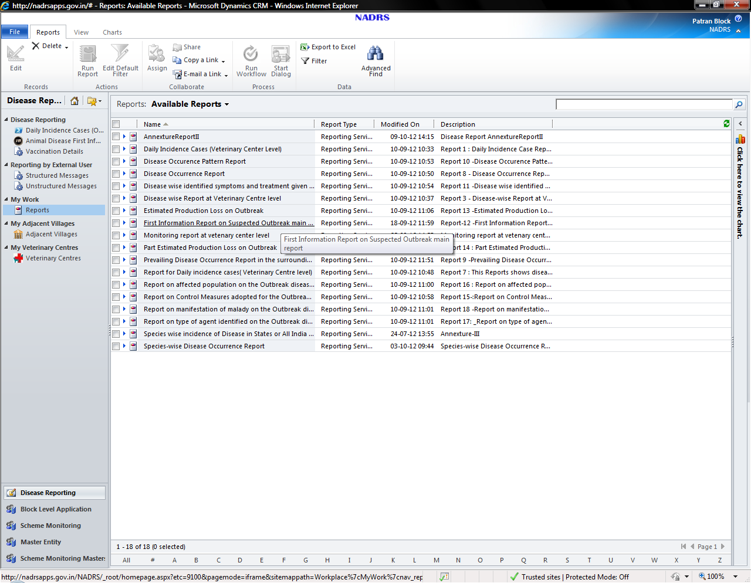

To view the report, double click the desired report

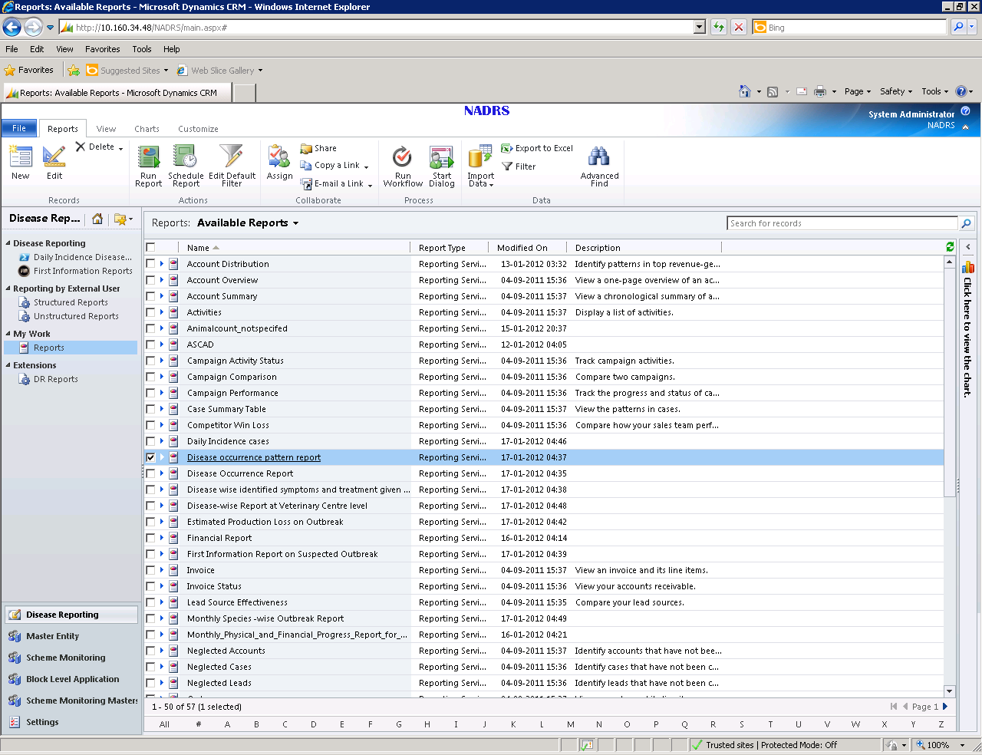



The screen will be displayed as shown below. The user has to enter the values of the required parameters for which report is to be generated and press **View Report** button on the right side. The report will be displayed in the bottom frame of the screen

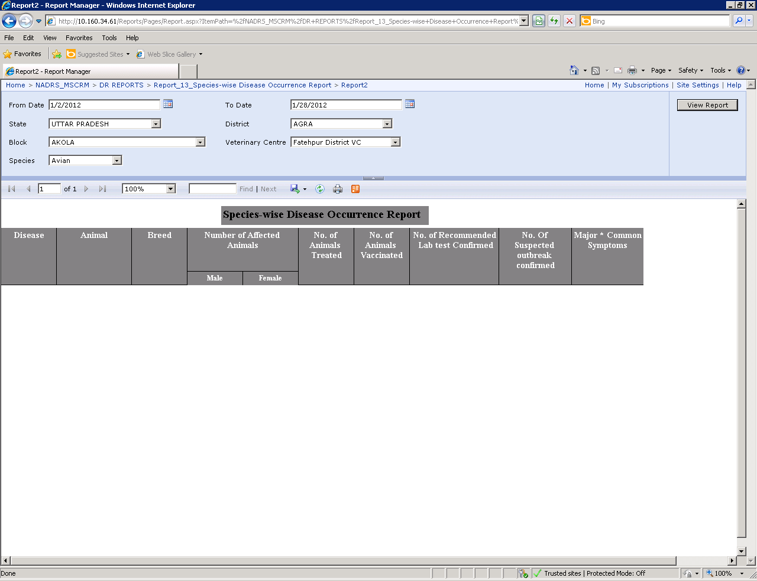

Parameter Frame

View Report Button

Report

# Disease Reporting By External User

There is provision in NADRS system to report the animal diseases using SMS, IVRS system and web based interface provided for it on NADRS portal. These reporting can be in unstructured format. In case disease is reported by the user registered on NADRS web portal, his details will be captured by the system and disease reported by him will be forwarded to concerned block level officer. In case it is by un-registered user, then it will be forwarded at central level. From central level it will be forwarded to the concerned location.

## View an Unstructured Report submitted by external User

|  |  |
| --- | --- |
| 9. | View an unstructured Report.  Unstructured report created by external user, internal user can’t change any Content; unstructured report can be created through SMS, Email, and IVRS.     * Click to select a record from the right side view.      * Double click to open the selected record. * Unstructured form will open.      * Date of Reporting – Date on which the report hascome. * Mobile number- Mobile number of the user who reported thedisease. * Message Mode- Message mode of the unstructured report, either it will come from SMS or IVRS or Email. * Message – Message which external user sent to NADRS. * Email – Email of the external user.   Filter View for unstructured Report.   * Select the message you want to view from right side view header.      * All Unstructured Reports – It is a default view, this will show all unstructured reports. * Reports by SMS- This view will show only reports by SMS. * Reports by Email –This view will show only reports by email. * Reports by IVRS- This view will show only reports by IVRS.   *User can See the unstructured form data but cannot change or update any record. |

## Analyze a structured Report

|  |  |
| --- | --- |
| 10. | View a structured report.   * Click Structured Report option from the left pane of navigation area.      * Select one record which you want to see and double click on that particular record to view the details. * Structured report form will open.      * Date of Reporting – Date on which the structured report has been created. * Unstructured Report – Unstructured report which is converted in to structured report. * Message Mode – mode on which that unstructured report has been created, web option is also included here. * SMS/IVRS/WEB/Email Message – Message on the unstructured report * Validity Message Mode- Message validity options available are spam, confirmed, not confirmed, No action required. * Animal – Animal name identified from unstructured message. * Disease – Disease name identified from unstructured message. * Clinical Symptom 1 – Clinical Symptom 1 identified from unstructured message. * Clinical Symptom 2 – Clinical Symptom 2 identified from unstructured message. * Clinical Symptom 3 – Clinical Symptom 3 identified from unstructured message. * Click on save and close button from the top left corner from the form. |

# Annexure - I

# Keyboard Shortcuts

|  |  |
| --- | --- |
| **Shortcuts for editing text** |  |
| Select all text in the current field | Ctrl+A |
| Copy text | Ctrl+C |
| Paste text | Ctrl+V |
| Cut text | Ctrl+X or Delete |
| Move the text insert point to the start of the next word | Ctrl+Right Arrow |
| Move the insertion point to the start of the previous word | Ctrl+Left Arrow |
| Undo previous text change | Ctrl+Z |
|  |  |
| **Shortcuts for lists** |  |
| Select all records on the current page | Ctrl+A |
| Open the selected record | Enter |
| Open the recently viewed pages and view menu | Ctrl+Shift+7 |
| Select multiple rows in a list sequentially | Shift+Up Arrow or Shift+Down Arrow |
| Select multiple rows in a list non-sequentially | Tab to the check box and Spacebar |
|  |  |
| **Shortcuts for menus & navigation** |  |
| Move to the first tab on the ribbon | Ctrl+[ |
| Move to the last tab on the ribbon | Ctrl+] |
| Cancel the current task or command, or close a selected list or dialog box | Esc |
| Display the shortcut menu for the selected item | Shift+F10 |
| Move to the next option or option group | Tab |
| Move to the previous option or option group | Shift+Tab |
| Action the command on the current active option or button | Enter |
|  |  |
| **Shortcuts to Close records** |  |
| Save a record | Ctrl+S |
| Save and close | Alt+S |
| Save and then create a new record | Ctrl+Shift+S |
| Delete the record | Ctrl+D |
|  |  |
| **Shortcuts to Browse records** |  |
| Open the list menu e.g. if you are in an account record this will open up the list of other accounts you can browse to | Ctrl+Shift+2 |
| Navigate to the next record in the list | Ctrl+> |
| Navigate to the previous item on the list | Ctrl+< |

# Annexure - II

# Animal Disease Reporting – Workflow

## Daily Incidence Case



## First Information Report (FIR)



# Annexure - III

# Reports

1. **Daily Incidence cases** Report for (Veterinary) centre of Block (District) in the (state name) for the period from (date) to (date)

Species Name:

|  |  |  |  |  |  |  |  |  |
| --- | --- | --- | --- | --- | --- | --- | --- | --- |
| Date | Disease name | Animal | Breed | Age | Sex | Symptoms / Diagnosis | Treatment | Remarks |
|  |  |  |  |  |  |  |  |  |
|  |  |  |  |  |  |  |  |  |
|  |  |  |  |  |  |  |  |  |
|  |  |  |  |  |  |  |  |  |

1. **Species-wise Disease Occurrence Report**

(Report have option to generate any day, range of the days, month, range of the months, year)

State: District Name:

Block Name: Veterinary Centre:

Species:

From Date: To Date:

|  |  |  |  |  |  |  |  |  |  |  |
| --- | --- | --- | --- | --- | --- | --- | --- | --- | --- | --- |
| Sr. No. | Disease | Animal | Breed | Number of Affected Animals | | No. of Animals Treated | No. of Animals Vaccinated | No. of Recommended  Lab test as Confirmed | No. of Suspected outbreak confirmed | Major *  Common  Symptoms |
| Male | Female |
|  |  |  |  |  |  |  |  |  |  |  |
|  |  |  |  |  |  |  |  |  |  |  |
|  |  |  |  |  |  |  |  |  |  |  |

1. **Disease-wise Report at Veterinary Centre level**

(Report have option to generate any day, range of the days, month, range of the months, year)

State: District Name:

Block Name: Veterinary Centre:

Disease:

From Date:

Species: To Date:

|  |  |  |  |  |  |  |  |  |  |  |
| --- | --- | --- | --- | --- | --- | --- | --- | --- | --- | --- |
| Sr. No. |  | Animal | Breed | Number of Affected Animals | | No. of Animals Treated | No. of Animals Vaccinated | No. of Recommended  Lab test as Confirmed | No. Of Suspected outbreak confirmed | Major *  Common  Symptoms |
| Male | Female |
|  |  |  |  |  |  |  |  |  |  |  |
|  |  |  |  |  |  |  |  |  |  |  |
|  |  |  |  |  |  |  |  |  |  |  |

1. **Monthly Species -wise Outbreak Report**

State: District:

Block: Month:

|  |  |  |  |  |  |  |  |  |  |  |  |
| --- | --- | --- | --- | --- | --- | --- | --- | --- | --- | --- | --- |
| Veterinary Centre | Disease | Whether Confirmed | Total No. of Outbreak | Species | Number of animals | | | | | | |
|  |  |  |  |  | Affected | Susceptible | Dead | Destroyed | Slaughtered | Treated | Vaccinated |
|  |  |  |  |  |  |  |  |  |  |  |  |
|  |  |  |  |  |  |  |  |  |  |  |  |
|  |  |  |  |  |  |  |  |  |  |  |  |

1. **Animals affected by different disease for specified range of percentage in particular Block/District/State**

State Name: District Name: Block Name:

Range of the Date/Month/Year percentage of affected animals by different diseases:

|  |  |  |  |  |  |  |  |  |
| --- | --- | --- | --- | --- | --- | --- | --- | --- |
| Dispensary Name | Village / Block/  District/  State | Disease name | Species name | Animals name | Breed name | Range of Date/Range of Month/  Year (Dynamically changed based on input) | | |
| No. of Animals affected | No. of Animals vaccinated | No. of Repeated cases for curing the disease |
|  |  |  |  |  |  |  |  |  |
|  |  |  |  |  |  |  |  |  |

No. of villages for which data has been reported:

This report will help in understanding major diseases occurring in the particular area

1. **Comparison of Animals affected by Diseases in the specified period range of the current year and previous year**

State Name: District Name: Block Name:

Range Date/Month/year

|  |  |  |  |  |  |  |  |  |  |  |
| --- | --- | --- | --- | --- | --- | --- | --- | --- | --- | --- |
| Dispensary Name | Village / Block /  District/  State | Disease name | Species name | Animals name | Range Date/Month/Year | | | Previous year’s  Range Date/Month/Year | | |
| No. of Animals affected | No. of Animals vaccinated | No. of Repeated cases for curing the disease | No. of Animals affected | No. of Animals vaccinated | No. of Repeated cases for curing the disease |
|  |  |  |  |  |  |  |  |  |  |  |
|  |  |  |  |  |  |  |  |  |  |  |

No. of villages for which data has been reported:

1. **Reports for Daily incidence cases ( Veterinary Centre level) \***

(Report has option to be generated for a day, range of the days, month, range of the months and year)

State Name: District Name:

Block Name: Veterinary Centre Name:

From Date: To Date:

|  |  |  |  |  |  |  |  |  |  |  |  |  |  |  |  |  |  |  |  |  |  |  |  |  |  |  |  |  |  |  |  |  |  |
| --- | --- | --- | --- | --- | --- | --- | --- | --- | --- | --- | --- | --- | --- | --- | --- | --- | --- | --- | --- | --- | --- | --- | --- | --- | --- | --- | --- | --- | --- | --- | --- | --- | --- |
| Sr. No. | Disease Name | Species Name | Animal Name | Breed Name | Age | Adult | | | | | | Young | | | | | | Not Specified (NS) | | | | | | | | | | | | Number of Animals | | No. of Lab Test recommended | No. of Suspected Outbreak |
| Male | | | Female | | | Male | | | Female | | | Male | | | | Female | | | | NS | | | | Vaccinated | Treated |
| Exotic | Indigenous | Crossbreed | Exotic | Indigenous | Crossbreed | Exotic | Indigenous | Crossbreed | Exotic | Indigenous | Crossbreed | Exotic | Indigenous | Crossbreed | NS | Exotic | Indigenous | Crossbreed | NS | Exotic | Indigenous | Crossbreed | NS |  |  |  |  | |
|  |  |  |  |  |  |  |  |  |  |  |  |  |  |  |  |  |  |  |  |  |  |  |  |  |  |  |  |  |  |  |  |  |  | |
|  |  |  |  |  |  |  |  |  |  |  |  |  |  |  |  |  |  |  |  |  |  |  |  |  |  |  |  |  |  |  |  |  |  | |
|  |  |  |  |  |  |  |  |  |  |  |  |  |  |  |  |  |  |  |  |  |  |  |  |  |  |  |  |  |  |  |  |  |  | |
|  |  |  |  |  |  |  |  |  |  |  |  |  |  |  |  |  |  |  |  |  |  |  |  |  |  |  |  |  |  |  |  |  |  | |
|  |  |  |  |  |  |  |  |  |  |  |  |  |  |  |  |  |  |  |  |  |  |  |  |  |  |  |  |  |  |  |  |  |  | |

The same type of Report available for Block/District/Region/State/Centre level

**Report Use: 360* view on occurrence of disease and its classified details**

1. **Disease Occurrence Report (Each parameter wise from highest occurrence to lowest occurrence)**

(Report has option to be generated for a day, range of the days, month, range of the months and year)

State Name: District Name:

Block Name: Veterinary Centre Name:

From Date: To Date:

|  |  |  |  |  |  |  |  |  |  |  |
| --- | --- | --- | --- | --- | --- | --- | --- | --- | --- | --- |
| Sr. No. | Disease Name | Species Name | Animal Name | Number of Affected Animals | | No. of Animals Treated | No. of Animal Vaccinated | No. of Recommended Lab test Confirmed | No. of Suspected outbreak confirmed | Major *  Common  Symptoms |
| Male | Female |
|  |  |  |  |  |  |  |  |  |  |  |
|  |  |  |  |  |  |  |  |  |  |  |
|  |  |  |  |  |  |  |  |  |  |  |

*out of reported clinical symptoms few common symptoms will be printed for each disease.

**Report Use: Highest order occurrence of the disease and its impacts.**

1. **Prevailing Disease occurrence report in the surrounding dispensaries covered area**

(Provision of Check box to choose the dispensaries located in surrounding areas as per user’s choice and the combo list option to choose top 1 to 10 occurrence of the disease from daily cases)

From Date: To Date:

|  |  |  |  |  |  |  |  |  |  |  |
| --- | --- | --- | --- | --- | --- | --- | --- | --- | --- | --- |
| Sr. No. | Veterinary Centre Name | Disease Name | Species Name | Animal  Name | No. of  Affected  Animals | No. of Animals Treated | No. of Animal Vaccinated | No. of Recommended Lab test Confirmed | No. of Suspected outbreak confirmed | Major *  Common  Symptoms |
| 1. | Name of the Dispensary  (Block Name)  (District Name)  (State Name) |  |  |  |  |  |  |  |  |  |
| 2 |  |  |  |  |  |  |  |  |  |  |
| 3 |  |  |  |  |  |  |  |  |  |  |

*out of reported clinical symptoms few common symptoms will be printed for each disease.

**Report Use: Awareness for the disease occurrence situation in the neighborhood areas**

1. **Disease occurrence pattern report**

(Report has option to be generated for any week, month, and year for any dispensary)

(Provision of Check box to choose the dispensaries located in surrounding areas as per user’s choice and the combo list option to choose top 1 to 10 occurrence of the disease from daily cases)

State Name: District Name:

Block Name:

|  |  |  |  |  |  |  |  |  |  |  |
| --- | --- | --- | --- | --- | --- | --- | --- | --- | --- | --- |
| Sr. No. | Veterinary Centre Name | Disease Name | Species Name | Animal  Name | Current week/current month/current year ( any one option at a time) | | | Previous year period of same week/month/year | | |
| No. of  Affected  Animals | No. Of Suspected outbreak confirmed | Major *  Common  Symptoms | No. of  Affected  Animals | No. Of Suspected outbreak confirmed | Major *  Common  Symptoms |
| 1. | Name of the Dispensary  (Block Name)  (District Name)  (State Name) |  |  |  |  |  |  |  |  |  |
| 2 |  |  |  |  |  |  |  |  |  |  |
| 3 |  |  |  |  |  |  |  |  |  |  |

*out of reported clinical symptoms few common symptoms will be printed for each disease.

**Report Use: It will help to identify the disease occurrence pattern of the present week/month/year with respect to week/month/year of previous year based on the local climatic conditions and other situations.**

1. **Disease wise identified symptoms and treatment given report**

(Report has option to be generated for any week, month, and year for any dispensary)

(Provision of Check box to choose the dispensaries located in surrounding areas as per user’s choice and the combo list option to choose top 1 to 10 occurrence of the disease from daily cases)

State Name: District Name:

Block Name: Week/Month/Year:

|  |  |  |  |  |  |  |
| --- | --- | --- | --- | --- | --- | --- |
| Sr. No. | Veterinary Centre Name | Disease Name | Species Name | Animal  Name | Major Common Symptoms* | Most commonly Recommended medicines** |
| 1. |  |  |  |  |  |  |
| 2. |  |  |  |  |  |  |
| 3. |  |  |  |  |  |  |

*out of reported clinical symptoms few common symptoms may be listed for each disease/species/animal.

** Out of recommended medicine most commonly (repeatedly) prescribed medicine of few may be listed for each disease/species/animal

**Report Use: It will be helpful for the veterinarian to know most common affected symptoms and recommended medicines for cure**

1. **First Information Report on Suspected Outbreak**

(Report has option to be generated for range of days, range of weeks, range of months, and any range of year from any dispensary/any block/any district/any state/whole country)

Report has option to specify choice outbreak Confirmed/Not Confirmed/Under Investigation/all cases

Report has options to specify outbreak reported as direct cases/Daily incidence cases

Outbreak Unique Id shown **with hyperlink to show exhaustive report** on this outbreak on click

|  |  |  |  |  |  |  |  |  |  |  |  |  |  |  |  |
| --- | --- | --- | --- | --- | --- | --- | --- | --- | --- | --- | --- | --- | --- | --- | --- |
| Sr. No. | Veterinary Centre Name | Disease Name | Species Name | Source of Animal Living Area | Data of | | Number of Animals | | Source of Infection | Disease Mode of Introduction | Disease Mode of Identification | | | Clinical Symptoms | Outbreak  Unique Id |
| Visit | Initial Occurrence | Affected | Death | Exotic | Indigenous | Crossbred |
| 1. | Name of the Dispensary  (Block Name)  (District Name)  (State Name) |  |  |  |  |  |  |  |  |  |  | | |  |  |
| 2 |  |  |  |  |  |  |  |  |  |  |  | | |  |  |
| 3 |  |  |  |  |  |  |  |  |  |  |  | | |  |  |

**Report Use: Initial view of FIR on outbreak and its impacts**

1. **Estimated Production Loss on Outbreak**

(Report has option to specify range of days, range of weeks, range of months, and any range of year from any dispensary/any block/any district/any state/whole country)

Report has option to specify outbreak type (Type A or Type B or Type C or ALL type)

Report has option to generate list of Diseases with Check box based on the type of disease option opted.

Outbreak Unique Id shown **with hyperlink to show exhaustive report** of the outbreak on click

|  |  |  |  |  |  |  |  |  |  |  |  |  |  |  |  |
| --- | --- | --- | --- | --- | --- | --- | --- | --- | --- | --- | --- | --- | --- | --- | --- |
| Sr. No. | Veterinary Centre Name | Disease Name | Species Name | Animal  Name | Estimated Production loss on surviving Animals on Quantity | | | | | Estimated Production loss on surviving Animals on values | | | | | Outbreak Id |
| Milk  Qty | Meat  Qty | Eggs Qty | Wool Qty | Drought Bullock Power Days | Milk  value | Meat  value | Eggs value | Wool value | Drought Bullock Power Days (Value) |
| 1. | Name of the Dispensary  (Block Name)  (District Name)  (State Name) |  |  |  |  |  |  |  |  |  |  |  |  |  |  |
| 2 |  |  |  |  |  |  |  |  |  |  |  |  |  |  |  |
| 3 |  |  |  |  |  |  |  |  |  |  |  |  |  |  |  |

1. **Estimated Production Loss on Outbreak (Highest loss/lowest loss/Average Loss)**

(Report has option to specify range of days, range of weeks, range of months, and any range of year from any dispensary/any block/any district/any state/whole country)

Report has option to specify outbreak type (Type A or Type B or Type C or ALL type)

Report has option to generate list of Diseases with Check box based on the type of disease option opted.

Outbreak Unique Id shown **with hyperlink to show exhaustive report** of the outbreak on click

|  |  |  |  |  |  |  |  |  |  |  |  |  |  |  |
| --- | --- | --- | --- | --- | --- | --- | --- | --- | --- | --- | --- | --- | --- | --- |
| Sr. No. | Veterinary Centre Name | Range of days/  weeks/  months/  year | Disease Name | Estimated Production loss on surviving Animals on Quantity | | | | | Estimated Production loss on surviving Animals on values | | | | | Outbreak Id |
| Milk  Qty | Meat  Qty | Eggs Qty | Wool Qty | Drought Bullock Power Days | Milk  value | Meat  value | Eggs value | Wool value | Drought Bullock Power Days (Value) |
| 1. | Name of the Dispensary  (Block Name)  (District Name)  (State Name) |  |  |  |  |  |  |  |  |  |  |  |  |  |
| 2 |  |  |  |  |  |  |  |  |  |  |  |  |  |  |
| 3 |  |  |  |  |  |  |  |  |  |  |  |  |  |  |

1. **Report on Control Measures adopted for the Outbreak disease**

(Report has option to specify range of days, range of weeks, range of months, and any range of year from any dispensary/any block/any district/any state/whole country)

Report has option to specify outbreak type (Type A or Type B or Type C or ALL type)

Report has option to generate list of Diseases with Check box based on the type of disease option opted.

Outbreak Unique Id shown **with hyperlink to show exhaustive report** of the outbreak on click

Report has option to generate list of Diseases, related species Check box based on the type of disease option opted.

|  |  |  |  |  |  |
| --- | --- | --- | --- | --- | --- |
| Sr. No. | Veterinary Centre Name | Range of days/  weeks/  months/  year | Disease Name | Control Measures Adopted  (Vaccinated, Ring Vaccinated, Stamping out, segregated, deep burial, incineration etc ) | Outbreak Id |
| 1. | Name of the Dispensary  (Block Name)  (District Name)  (State Name) |  |  |  |  |
| 2 |  |  |  |  |  |
| 3 |  |  |  |  |  |

**Control measures adopted details only displayed on the selected ranges of days/weeks/months/year**

**Report Use: To know the date from when the control measures adopted after the outbreak occurred and how many days taken to adopt each control measure.**

1. **Report on affected population on the Outbreak disease**

(Report has option to specify range of days, range of weeks, range of months, and any range of year from any dispensary/any block/any district/any state/whole country)

Report has option to specify outbreak type (Type A or Type B or Type C or ALL type)

Report has option to generate list of Diseases with Check box based on the type of disease option opted.

Outbreak Unique Id shown **with hyperlink to show exhaustive report** of the outbreak on click

|  |  |  |  |  |  |
| --- | --- | --- | --- | --- | --- |
| Sr. No. | Veterinary Centre Name | Range of days/  weeks/  months/  year | Disease Name | Affected Population  (Grazing Population, Stall-fed population, Breeding Stock, fattening Stock, individual herds, collective herds) | Outbreak Id |
| 1. | Name of the Dispensary  (Block Name)  (District Name)  (State Name) |  |  |  |  |
| 2 |  |  |  |  |  |
| 3 |  |  |  |  |  |

**Report Use: To know when the different type of animal population getting affected on outbreak and also to know which type disease affected what type of animal population first and further spread to what type of animals.**

1. **Report on type of agent identified on the Outbreak disease**

(Report has option to specify range of days, range of weeks, range of months, and any range of year from any dispensary/any block/any district/any state/whole country)

Report has option to specify outbreak type (Type A or Type B or Type C or ALL type)

Report has option to generate list of Diseases with Check box based on the type of disease option opted.

Outbreak Unique Id shown **with hyperlink to show exhaustive report** of the outbreak on click

|  |  |  |  |  |  |
| --- | --- | --- | --- | --- | --- |
| Sr. No. | Veterinary Centre Name | Range of days/  weeks/  months/  year | Disease Name | Type of Agent  (Viral, Bacterial, Parasitic, Protozoan etc ) | Outbreak Id |
| 1. | Name of the Dispensary  (Block Name)  (District Name)  (State Name) |  |  |  |  |
| 2 |  |  |  |  |  |
| 3 |  |  |  |  |  |

**Report Use: To know type of agent identified during the period of outbreak and also to know which type of disease caused by agent first and spread further.**

1. **Report on manifestation of malady on the Outbreak disease**

(Report has option to specify range of days, range of weeks, range of months, and any range of year from any dispensary/any block/any district/any state/whole country)

Report has option to specify outbreak type (Type A or Type B or Type C or ALL type)

Report has option to generate list of Diseases with Check box based on the type of disease option opted.

Outbreak Unique Id shown **with hyperlink to show exhaustive report** of the outbreak on click

|  |  |  |  |  |  |
| --- | --- | --- | --- | --- | --- |
| Sr. No. | Veterinary Centre Name | Range of days/  weeks/  months/  year | Disease Name | Manifestation of Malady  (Virulent, Sub-clinical, Sporadic, Widespread, Localised,  Endemic, mild ) | Outbreak Id |
| 1. | Name of the Dispensary  (Block Name)  (District Name)  (State Name) |  |  |  |  |
| 2 |  |  |  |  |  |
| 3 |  |  |  |  |  |

**Report Use: Manifestation of malady identified during the period of outbreak**

National Animal Disease Reporting System

User Manual

District and State Level Users

Designed in-house at National Informatics Centre.

©Copyright 2010 NIC, DIT, MCIT

Animal Production and Health Informatics Division

A2B7, Sixth Floor

National Informatics centre

A-Block, CGO Complex

Lodhi Road, New Delhi – 3

INDIA

Email : nadrs@nic.in

Phone : 011-24362790

Fax : 011-24362790